Section 4

1. Describe, using the relevant physics, how moving a magnet near a solenoid induces a voltage across it. How does the speed of the magnet affect the voltage? What about turning the magnet upside down?

A moving magnet induces voltage because changes in flux, according to Faraday’s Law, will induce a current. The faster the magnet moves through the solenoid, the stronger the current. The orientation and speed of the magnet will affect the direction and the magnitude of the current. Because there is a current, there is automatically a movement of charges, and the creation of a charge differential meaning that there will be a voltage along the solenoid. If you flip the magnet, the magnetic field will be reversed, and there will be a current and a voltage going in the opposite direction.

Section 5

1. Describe how a signal generator putting changing current through the primary solenoid results in voltage in the secondary solenoid. How is this similar to the previous section with the moving magnet?

This is the principle of inductance working in the circuit. Inductance works with Faraday’s law, in which a moving magnetic field creates current and voltage. In this section, the signal generator created a sinusoidal wave, which meant that the voltage and current in the first solenoid was constantly changing. The Changing current induced another current in the second solenoid. As the current changed, so did the magnetic field in the first solenoid. The constant change in the magnetic field meant that an alternating current was also generated in the second solenoid. This follows similarly with the first question where the change in the magnetic field of one solenoid creates a second current in the second solenoid. There cannot be a current without a change in charge, and a change in charge means that there is a voltage.

1. The voltage in the secondary solenoid had maxima and minima for both the square and sine waves. In both cases what is the status of the current in the primary solenoid when the voltage in the secondary reaches one of these maxima or minima?

The current on the primary solenoid is generally just past a minimum as the voltage reaches a maximum (probably caused by delays in the reaction because of internal resistances), and the opposite is true when the voltage in the secondary solenoid is at a maximum. As for the square currents, every peak in the voltage corresponded with a drop in the current, and every rise in current corresponded with a drop in voltage.

1. Derive the relationship between the current in the primary solenoid and the voltage in the secondary. You may ignore any constants in your derivation. Does this confirm your answer to question 3?

$V(t)=-\frac{dI}{dt}$ $-\int{V\left(t\right)dt}=I$ This is because the change of current in the primary solenoid is followed by a reaction in the secondary solenoid that mirrors the rate of change in the primary solenoid, only that it is in the opposite direction. The reason that it is in the opposite direction can be explained using Lenz’s law, which states that the current produced in the secondary conductor due to Faraday’s law will resist and mirror the current and consequently the voltage in the primary solenoid. This law helps to confirm the answer to question 3 because the peaks in the voltage matched the negative slope of the changes in the current.

1. How does the magnitude of the induced voltage depend on the presence of the iron core? What physical property of the iron core causes this change?

The magnitude of the induced voltage went up when the iron core was inserted. This increase is due to the magnetic properties of iron. Iron is a paramagnetic material, meaning that the induced magnetic fields from the solenoid will flow in the same direction, meaning that this material would work as a multiplier to the magnitude of the induced magnetic field. Paramagnetic properties of a material are caused by a material’s valence electron makeup.

Section 6

1. Derive the steady state voltage of an inductor in an RL circuit with battery voltage, V, inductor resistance, RL, and additional resistance, R. Note that the inductor itself has resistance, so it always has some contributing voltage due to Ohm’s law. What happens to the voltage over the inductor due to Faraday’s law in the steady state?

Lenz’s Law

$ε= -\frac{dφ}{dt}$ Where epsilon is induced voltage

$V_{L}= -\frac{dφ}{dt}+IR_{L}$ Where RL is the resistance of the soilenoid

$V_{L}= -NA\frac{dB}{dt}+IR_{L}$ $B= μ\frac{N}{l}I$ A being the area of the circle within the solenoid

$V_{L}= -μ\frac{N^{2}}{l}A\frac{dI}{dt}+IR_{L}$ L = $-μ\frac{N^{2}}{l}A$

$V_{L}=L\frac{dI}{dt}+IR_{L}$

In this experiment, the inductor functions like a capacitor, storing charge in the circuit. Because of this, the storing of the charge “backs up” the circuit, causing the steady state voltage to be reduced to IRL, because the current eventually drops to zero, resulting in a reverse exponential function. $\left(\frac{dI}{dt}→0\right)$ as $(t→∞)$ is what can be drawn from the equation and from the calculations of the RL circuits.

Section 6.1

Measured Resistances and Inductances:

|  |  |
| --- | --- |
| 10Ω Resistor | 10.2 ± 0.1 Ω |
| 100Ω Resistor | 100.1 ± 0.1 Ω |
| 150mH inductance | 144.9 ± 0.1 mH |
| 150mH resistance | 163.4 ± 0.1 Ω |
| Circuit board Inductance w/o iron core | 8.0 ± 0.1 mH |
|  |  |
|  |  |

Total resistance for the 10 Ω circuit: (10.2 ± 0.1 Ω) + (163.4 ± 0.1 Ω) = 173.6 ± 0.2 Ω

Total resistance for the 100Ω circuit: (100.1 ± 0.1 Ω) + (163.4 ± 0.1 Ω) = 263.4 ± 0.2 Ω

The inverse exponential function was chosen because the decay of the voltage is similar to decay of voltage in a RC circuit graph in a previous experiment. This circuit behaved in a similar way to RC circuits, so the exponential function was chosen.

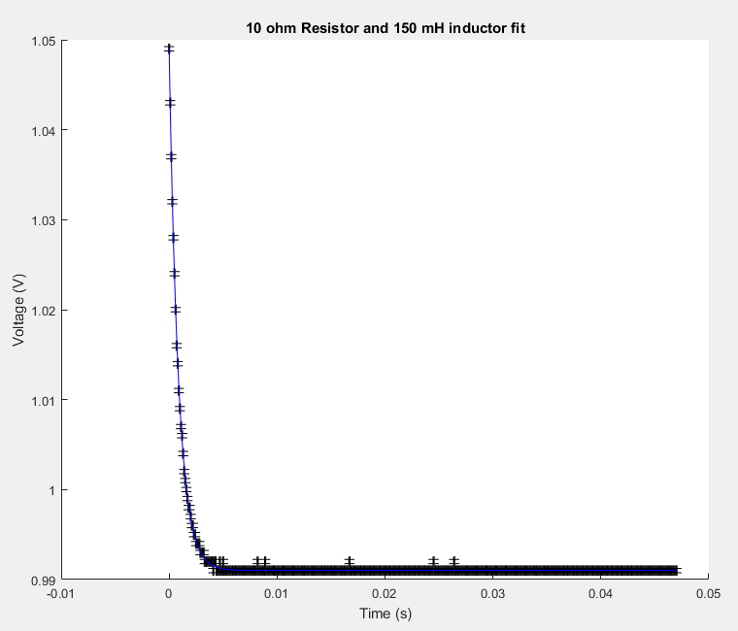

Parameter A = 5.807082e-02 +/- 9.887818e-05

Parameter tau = 8.636207e-04 +/- 2.244000e-06

Parameter B = 9.910168e-01 +/- 7.772749e-06

A = 0.0581 ± 0.0001 V = starting voltage

Τ = 0.000864 ± 0.000002 s

B = 0.991 ± 0.001 V = final voltage

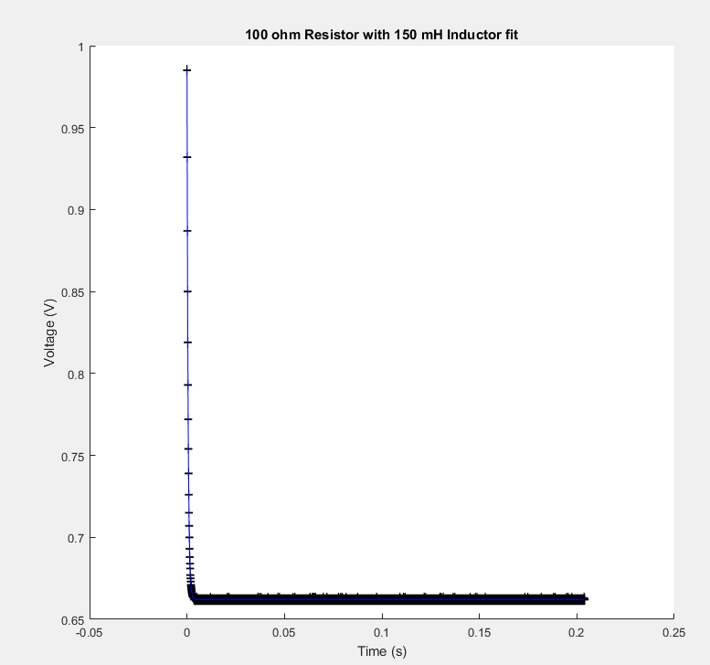

This was fitted to the exponential fit function. Due to the circuits in this lab behaving like the ones from the RC circuits in previous labs.

Parameter A = 3.226097e-01 +/- 1.227529e-04

Parameter tau = 5.565713e-04 +/- 3.276399e-07

Parameter B = 6.620301e-01 +/- 3.815224e-06

A = 0.3226 ± 0.0001 V = starting voltage

Τ = 0.0005566 ± 0.0000003 s

B = 0.662 ± 0.0001 V = ending voltage

$\frac{τ_{1}}{τ_{2}}, \frac{R_{1}}{R_{2}}$ $\frac{0.000846}{0.0005566}= 1.51994$ $\frac{173.6}{263.4}=0.6591$

The numbers are inverses of each other because the formula for tau = L/R, meaning that tau(R) = L, if tau goes up, R must come down.

Expected ratio = $\frac{R_{1}}{R_{2}}=1.5728$ Actual Ratio = 1.51994

T-score = $\frac{\left|x_{expt}-x_{thero}\right|}{\sqrt{σ_{expt}^{2}+σ_{thero}^{2}}}= \frac{\left|1.51994-1.5728\right|}{\sqrt{{0.00001}_{}^{2}+{0.01}_{}^{2}}}=5.285997$

Section 6.2

|  |  |
| --- | --- |
| Circuit board Inductance w/o iron core | 8.0 ± 0.1 mH |
| Circuit Board Inductance with Iron Core | 20.7 ± 0.1 mH |
| Circuit Board Inductor Resistance | 5.5 ± 0.1 Ω |
| Resistor resistance | 10.2 ± 0.1Ω |
| Total Circuit Resistance | 15.7 ± 0.2 Ω |

Iron Core Permittivity

$L= μ\frac{N^{2}A}{I}$ I is constant, N is constant, A is constant

$\frac{L}{μ}= \frac{N^{2}A}{I}$ because there is this point where $\frac{L}{μ}$ equals a constant, can equate equations with 2 different µ values. , area is small, can complete calculation using permittivity of free space

$\frac{L_{Fe}}{μ}= \frac{L_{no Fe}}{μ_{0}}$

$\frac{20.7 H}{μ}= \frac{0.008 H}{4π x {10}^{-7} H}$ $μ= \frac{4π x {10}^{-7} H}{0.008 H} x 20.7 H=3.25 x {10}^{-6}$ ± 0.04 x10-6 H

Without Iron Core

This exponential fit was chosen because of the similarity in graph shape and circuit properties of the RC circuit.

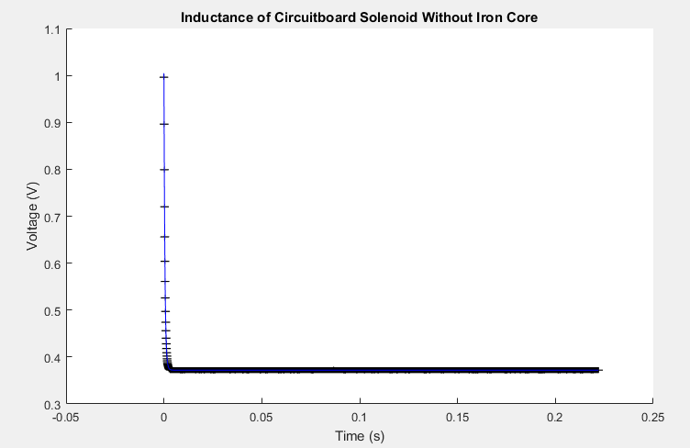

Parameter A = 6.322265e-01 +/- 2.436989e-04

Parameter tau = 4.968711e-04 +/- 2.991388e-07

Parameter B = 3.719532e-01 +/- 6.982548e-06

A = 0.6322 ± 0.0002 V = starting voltage

Tau = 0.0004969 ± 0.0000003 s

B = 0.371953 ± 0.000007 V = Resting Voltage

With Iron Core

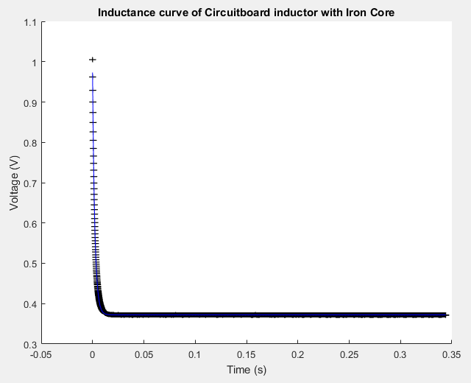

This exponential fit was chosen because of the similarity in graph shape and circuit properties of the RC circuit.

Parameter A = 6.001324e-01 +/- 4.478702e-04

Parameter tau = 2.236734e-03 +/- 2.429705e-06

Parameter B = 3.720594e-01 +/- 1.911809e-05

A = 0.6001 ± 0.0004 V = “Starting” Voltage

Tau = 0.002237 ± 0.000002 s

B = 0.37205 ± 0.00002 V = resting Voltage

Recalculation of µ

$τ= \frac{μ\frac{N^{2}A}{l}}{R_{total}}$ since A, N, l, and Rtotal are all constant, a ratio of the taus and the magnetic permittivity values can be constructed as $\frac{τ_{Fe}}{τ_{no Fe}}= \frac{μ_{Fe}}{μ_{0}}$

$$\frac{0.002237}{0.004969}= \frac{μ_{Fe}}{4π x {10}^{-7}}$$

$μ_{Fe}= \frac{0.002237}{0.004969} x 4π x {10}^{-7}=5.657 x {10}^{-7}±0.005 x {10}^{-7}$ experimental value

T-score = $\frac{\left|x_{expt}-x_{thero}\right|}{\sqrt{σ_{expt}^{2}+σ_{thero}^{2}}}= \frac{\left|5.657 x {10}^{-7}-3.25 x {10}^{-6}\right|}{\sqrt{{0.005 x {10}^{-7}}_{}^{2}+{0.04 x{10}^{-6}}_{}^{2}}}=67.1022$

Steady Current = $\frac{V_{source}}{R_{total}}=\frac{1 V}{15.5±0.2 Ω}=0.0645±0.0008 A$

Steady Voltage of Inductor = IRL= (0.0645 ± 0.0008A)(5.5±0.1Ω) = 0.355 ± 0.008 V

Experimental steady state voltage is parameter B from the MATLAB fit. If B did not exist, the equation would eventually go to zero.

T-score = $\frac{\left|x_{expt}-x_{thero}\right|}{\sqrt{σ_{expt}^{2}+σ_{thero}^{2}}}= \frac{\left|0.371953 V-0.355 V\right|}{\sqrt{{0.000007 V}_{}^{2}+{0.008}_{}^{2}}}=2.119$

Discussion

1st Point:

The frequency on the current only affects the rate at which the sign on the voltage is flipped and changed. The strength of the voltage readings is dependent on the magnitude of the magnetic field changes, which in turn are affected by the magnitude of the changes in the current. Since the magnitude of the current changes was not adjusted between settings of frequency, the voltage peaks and dips had an essentially constant magnitude.

If the current is a triangle wave, the voltage would be a square wave with the voltage value being at a negative peak while the current is rising and the voltage being a maximum where the current is falling. The graph results like this because of Lenz’s Law. The voltage, due to resistance to the magnetic field form the primary solenoid, will have a voltage and current that will be in the opposite direction of the current and magnetic field in the primary solenoid.